# HTML

1. <!DOCTYPE html>
2. Single or Double Quotes?
3. <html

* lang = "en”>
* lang = "en-US”>

1. <head>

* <meta
  + char set = “UTF-8”>
* <title>
* <link (Links the html file to other documents)
  + rel= “stylesheet”>
  + href=”style.css”>

1. <body>

* style="font-size:60px;">
* style= “color: red;”>
* style="background-color:powderblue;">
* style="font-family:courier;">
* align = “right”>

1. <section> (Create semantic standalone entities in webpages that can exist independently)
2. <ul> (Unordered List element)
3. <li> (List element item. Used to show a list element in a list: either ul or ol)
4. <ol> (Ordered List element)
5. <h1>

* style="font-size:60px;">
* style= “color: red;”>
* style="background-color:powderblue;">
* style="font-family:courier;">

1. <br>

* <p>This is<br>a paragraph<br>with line breaks.</p>

1. <hr>

* <hr>

1. <b>
2. <p

* title="I'm a tooltip">
* style= “color: red;”>
* style="font-size:60px;">
* style="background-color:powderblue;">
* style="font-family:courier;">

1. <a

* href =”link”> Link text </a>
* You can use href="#top" or href="#" to link to the top of the current page!

There are two ways to specify the URL in the src attribute:

* Absolute URL 🡺 src="https://www.w3schools.com/images/img_girl.jpg".
* Relative URL 🡺 src="/images/img_girl.jpg". **BETTER, NEED MORE INFO**

1. <img>

* src="img_girl.jpg">
* alt="Girl with a jacket">
* width= “1200”>
* height= “768”>

1. <pre>

* 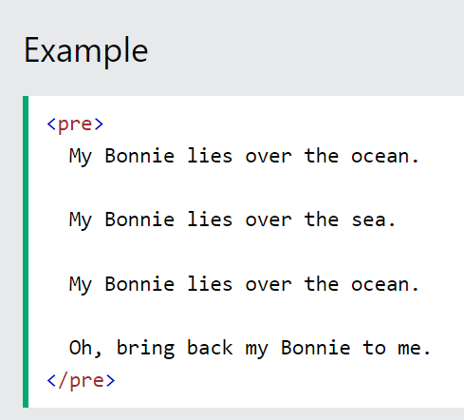

# CSS

* margin: 0;
* padding: 0;
* box-sizing: border box;
* font family: ‘arial’, sans-serif;
* **SECTION**
* position: relative;
* width: 100%;
* display: flex;
* justify-content: center;
* align-items: center;
* min-height: 100vh;
* **SECTION HEADER**
* position: absolute;
* top: 0;
* width:100%;
* display: flex;
* justify-content: flex-end;
* align-items: center;
* padding: 20px;
* **SECTION HEADER UL**
* display: flex;
* justify-content: center;
* align-items: center;

**SECTION HEADER UL LI**

* list-style: none;
* margin-left: 20 px;

**SECTION HEADER UL LI A**

<https://www.w3schools.com/tags/default.asp>